**COMPUTER SIMULATION**

The topology was tested by computer simulation at Simulink. Firstly, the computer simulations were done part by part and then, overall system were simulated.

**Three Phase Rectifier**

The three-phase rectifier are tested by only resistive load. The voltage ripple is 300 Hz and average voltage is $1.35Vll$.

The phase voltage is given as 230 Vrms with 10 ohm resistive load. It shows that only three-phase rectifier is not enough to obtain purely DC voltage.

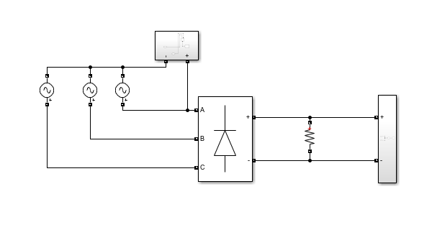

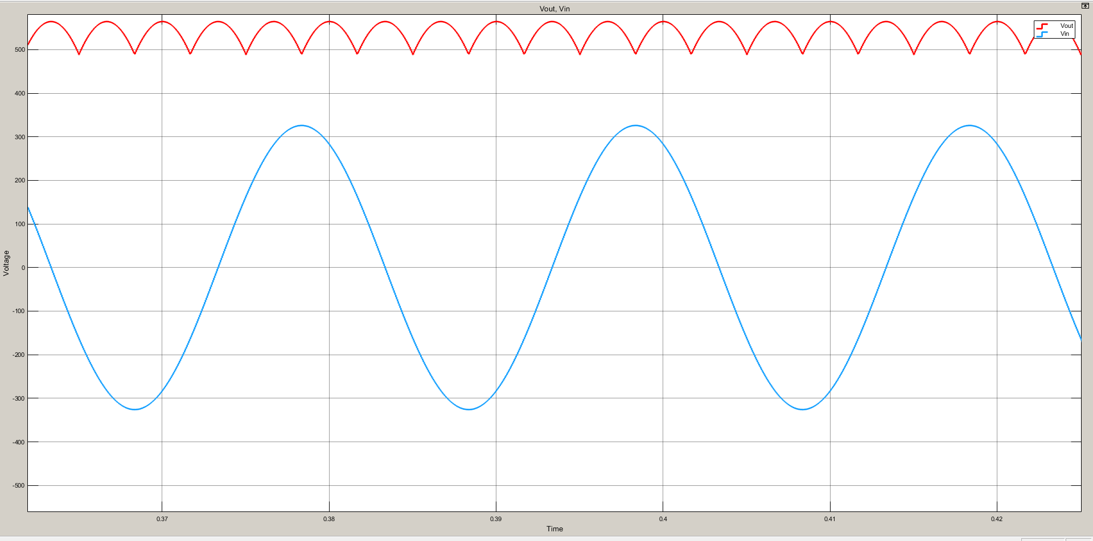

**DC LINK CAPACITOR**

The rectifier with DC link capacitor is tested with 100 ohm load. The DC link Capacitor is calculated for 800 micro farad.

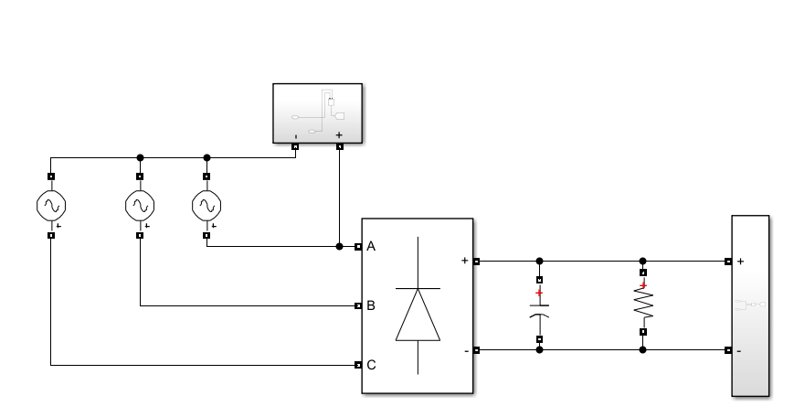

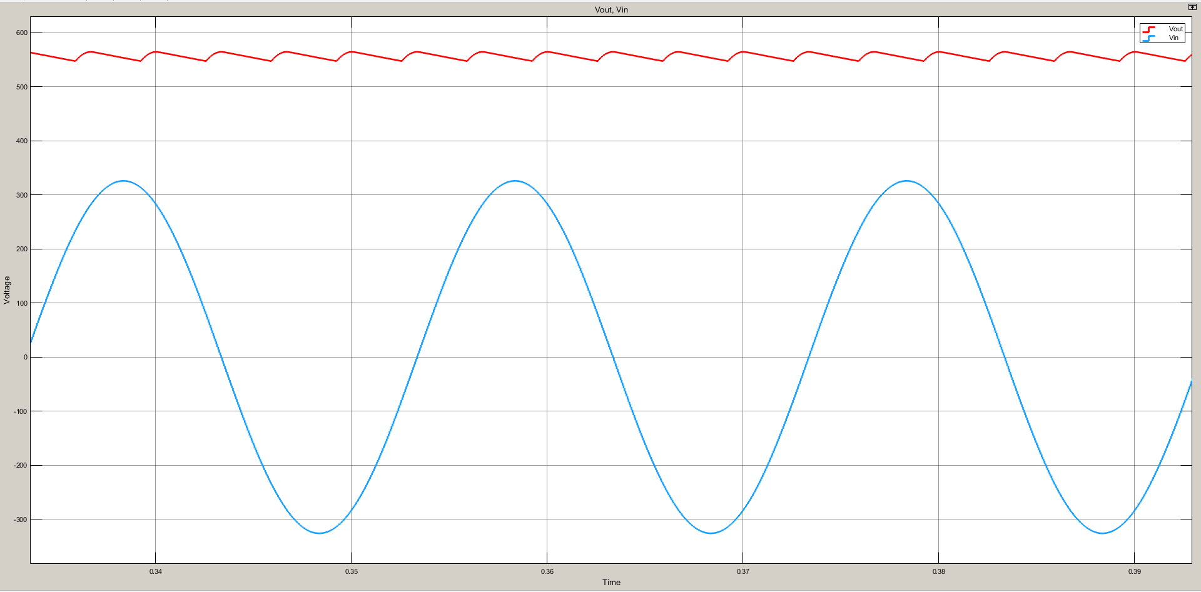

The voltage ripple decreases. The output voltage is closing to purely DC with link capacitance.

**PWM with R load**

PWM control is created by using 100-ohm resistive load with switching transistor. The input voltage is 200 V DC.

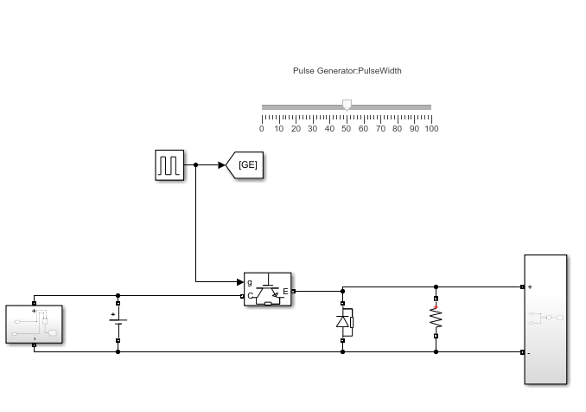

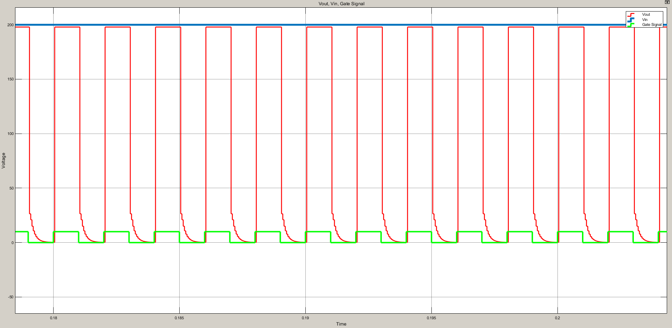

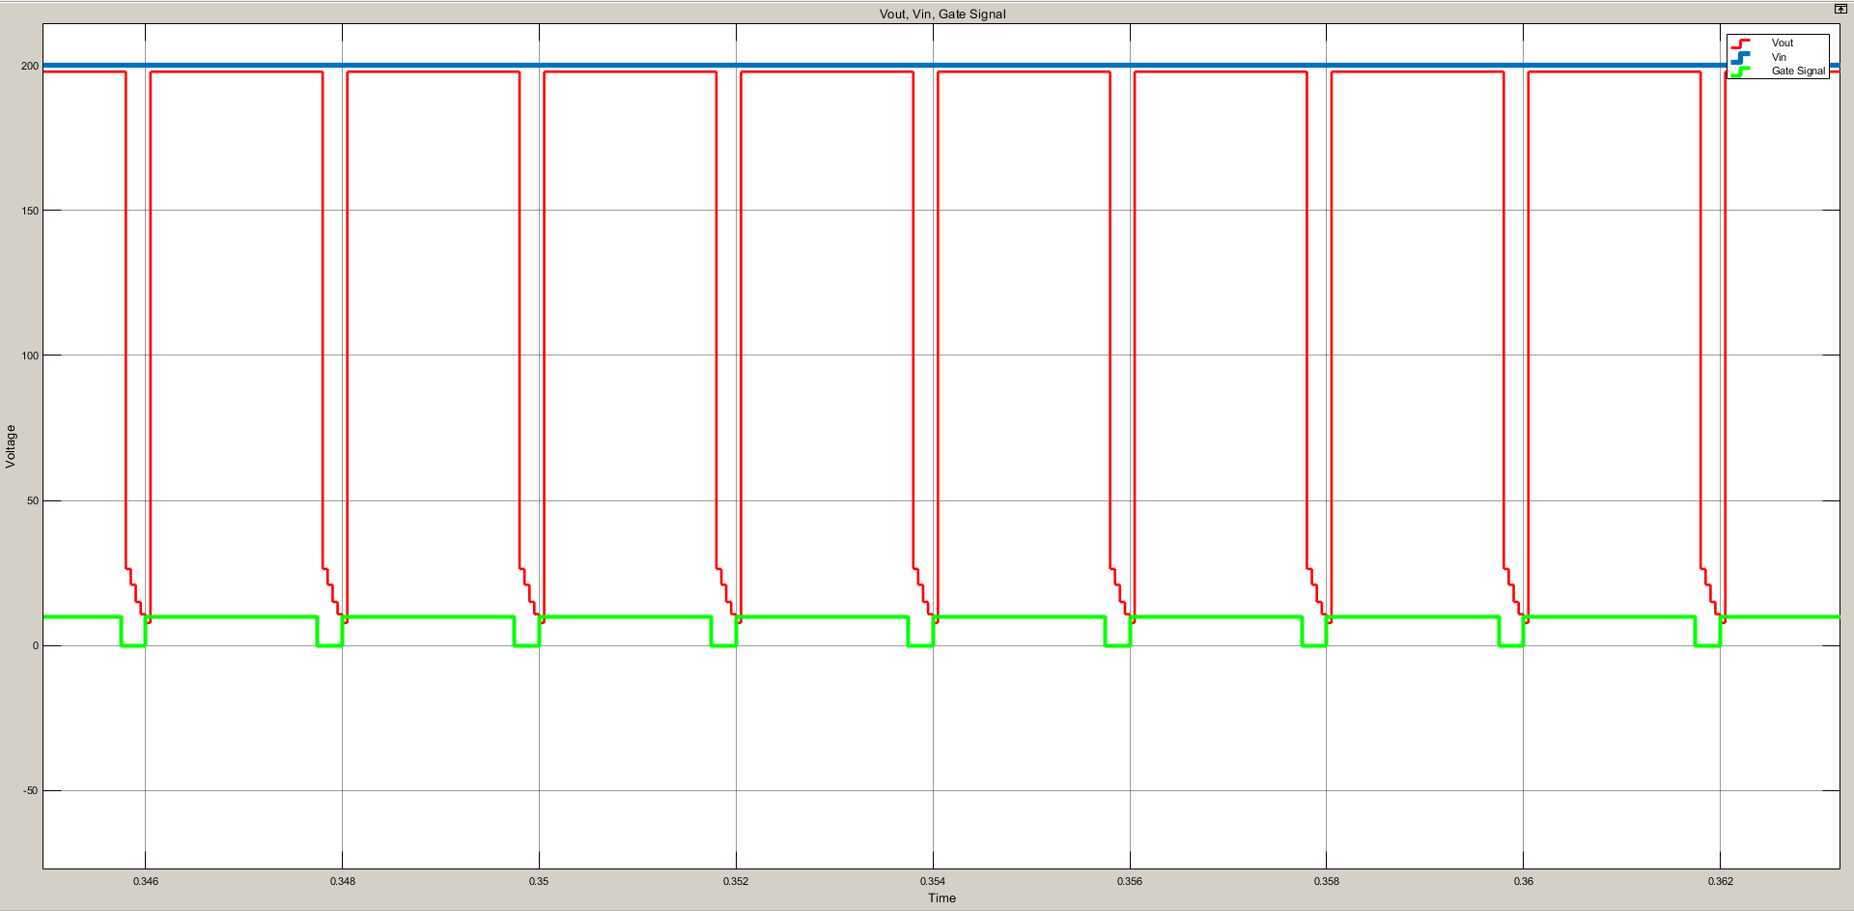

As seen simulation result, changing duty cycle affects directly output voltages.

**PWM with Motor**

The motor parameters are transferred into simulation environment. Then, the PWM control is tested by 220 V DC input.

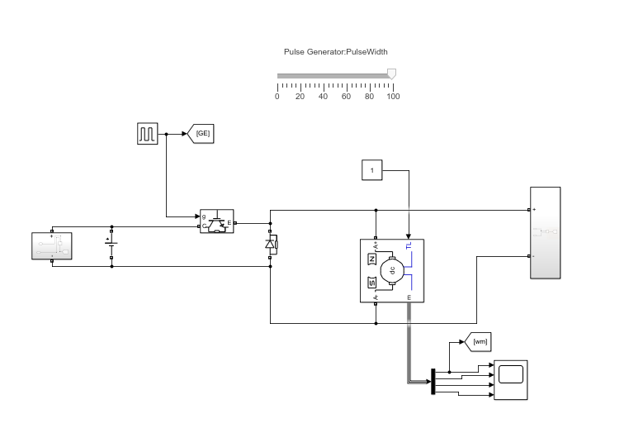

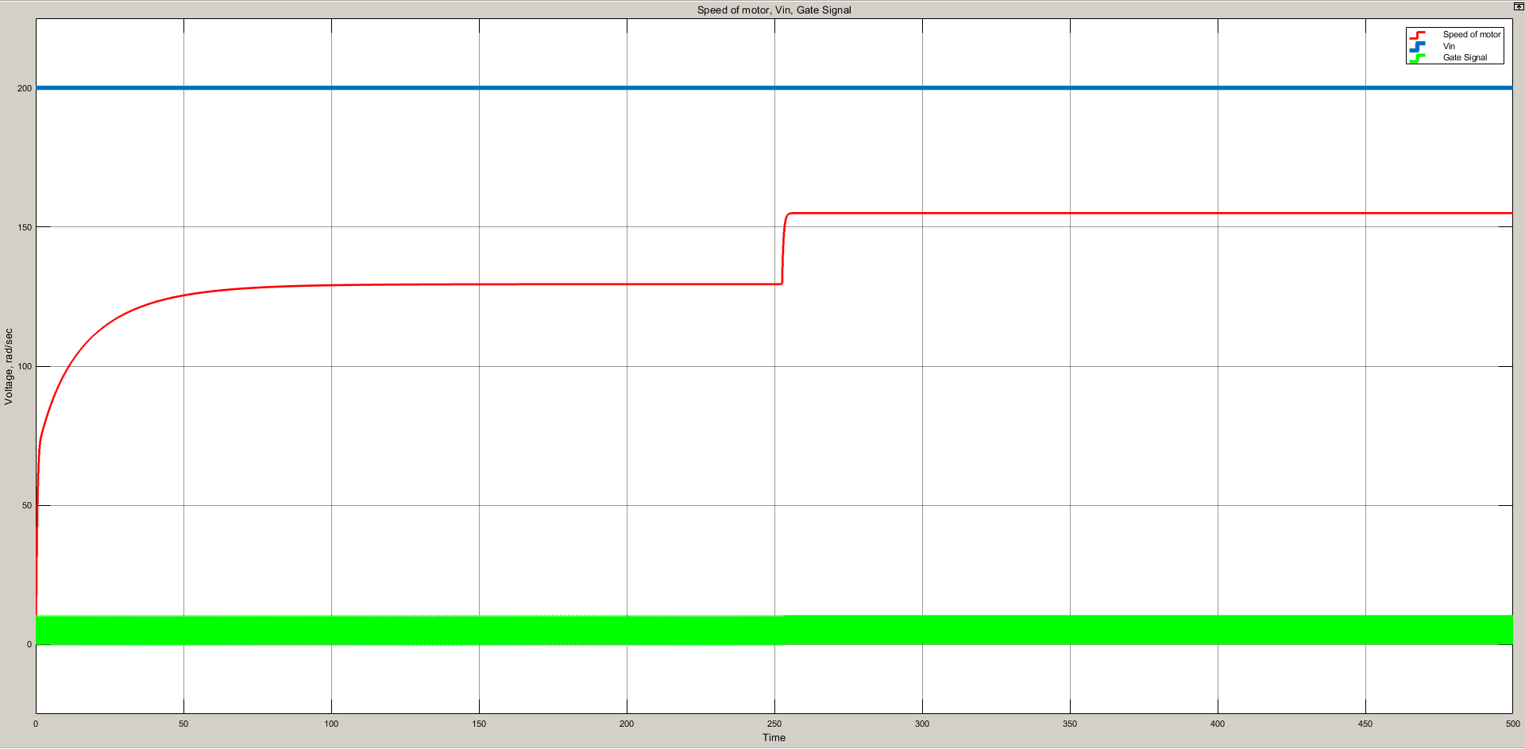

First 250 second, the duty cycle is 50 percent. Then, duty increased to 100 percent. The changes at motor speed was observed at Figure X. It shows that the motor speed can be controlled by PWM.

**Overall Simulation**

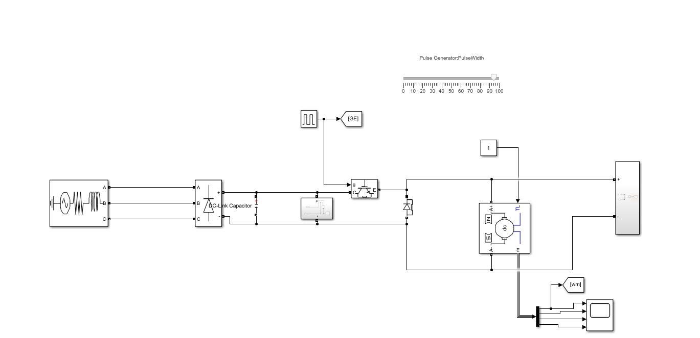

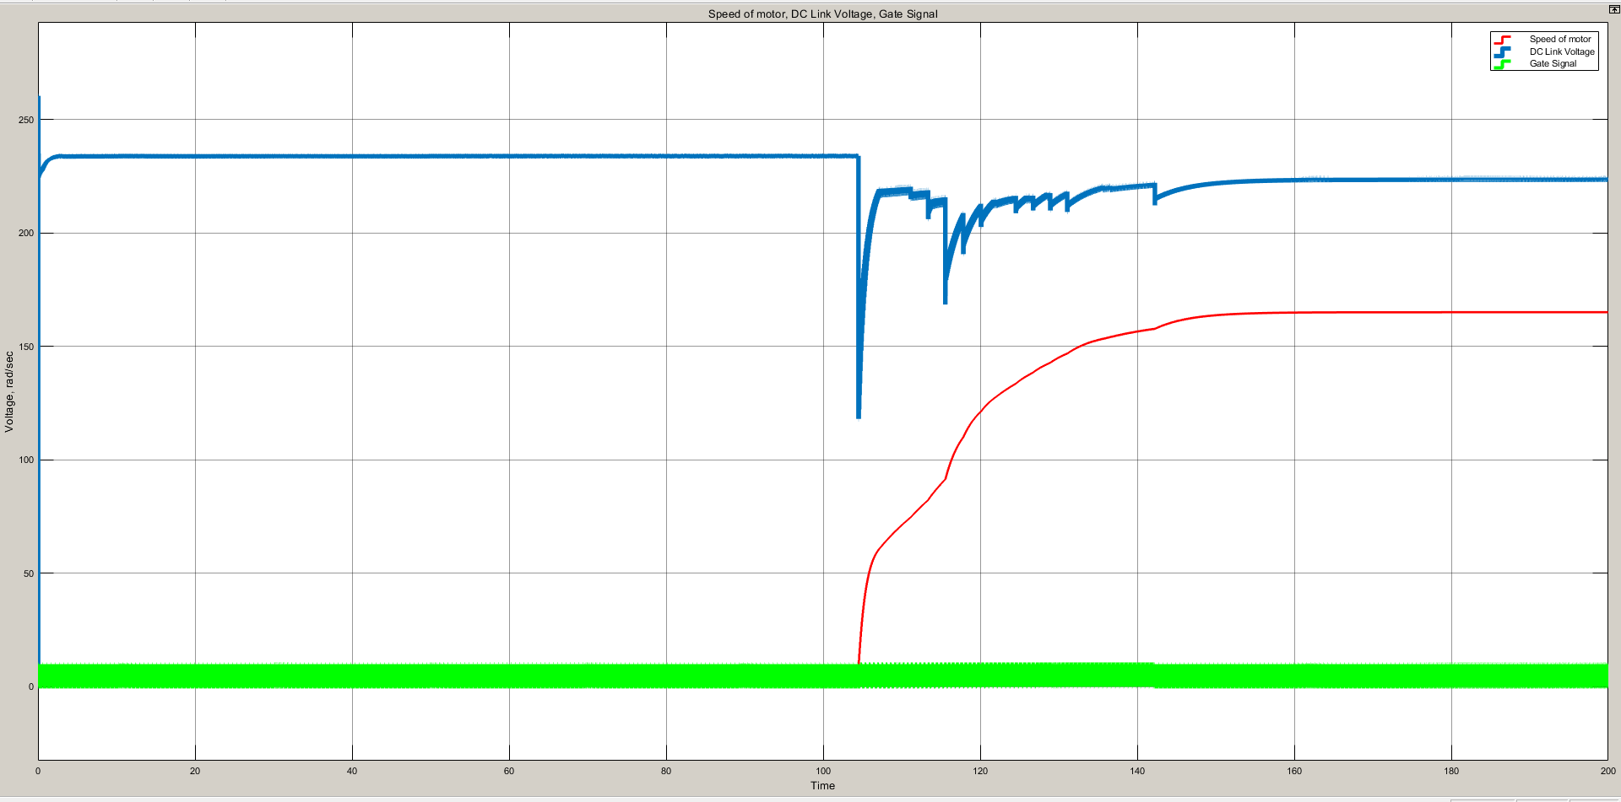

At this setup, firstly the duty is zero and the DC link capacitance were charged and the speed of the motor is zero due to zero duty cycle. Then, the duty increases to 100 percent and the speed of the motor increases. There is spike at transition between blocking and conduction mode.